* Go to AWS console and create one public and private instance.

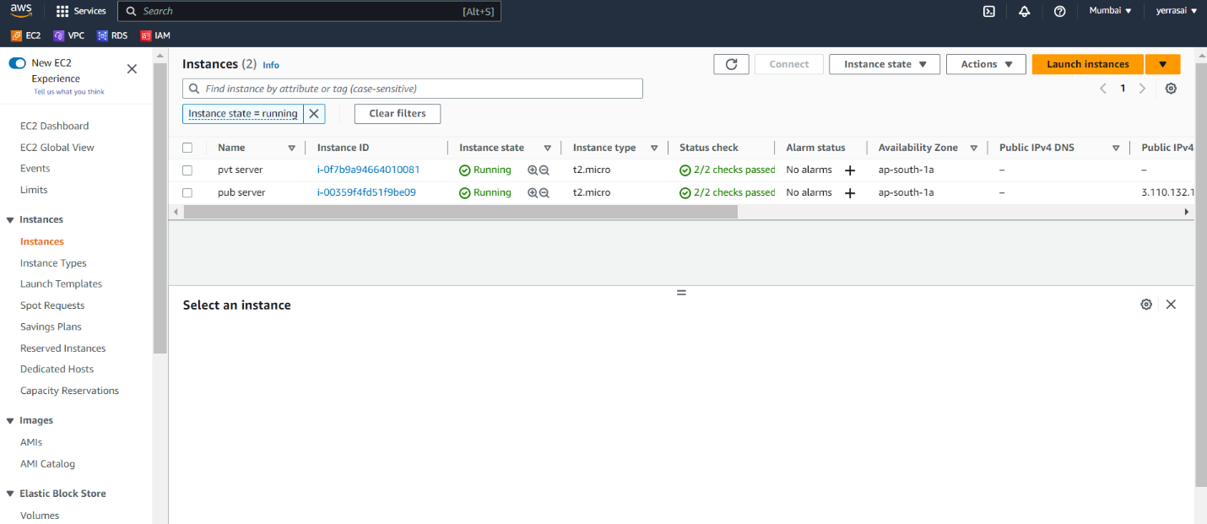

* Connect to instance.

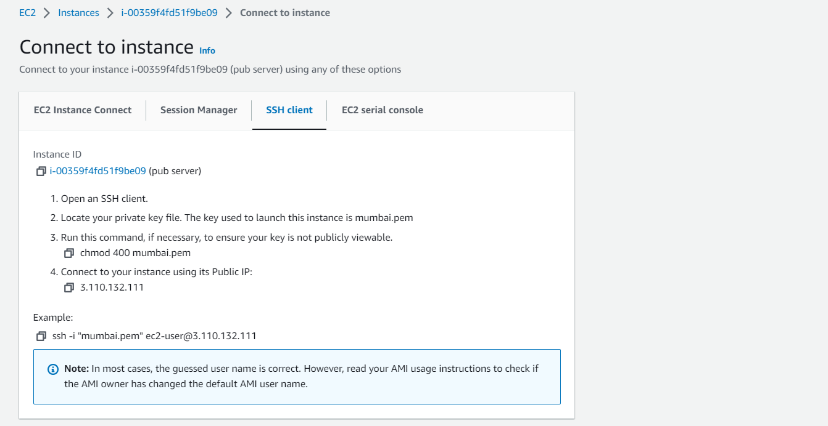

* Go to terminal and connect to that instance.
* By using touch command create a file : docker-compose.yaml

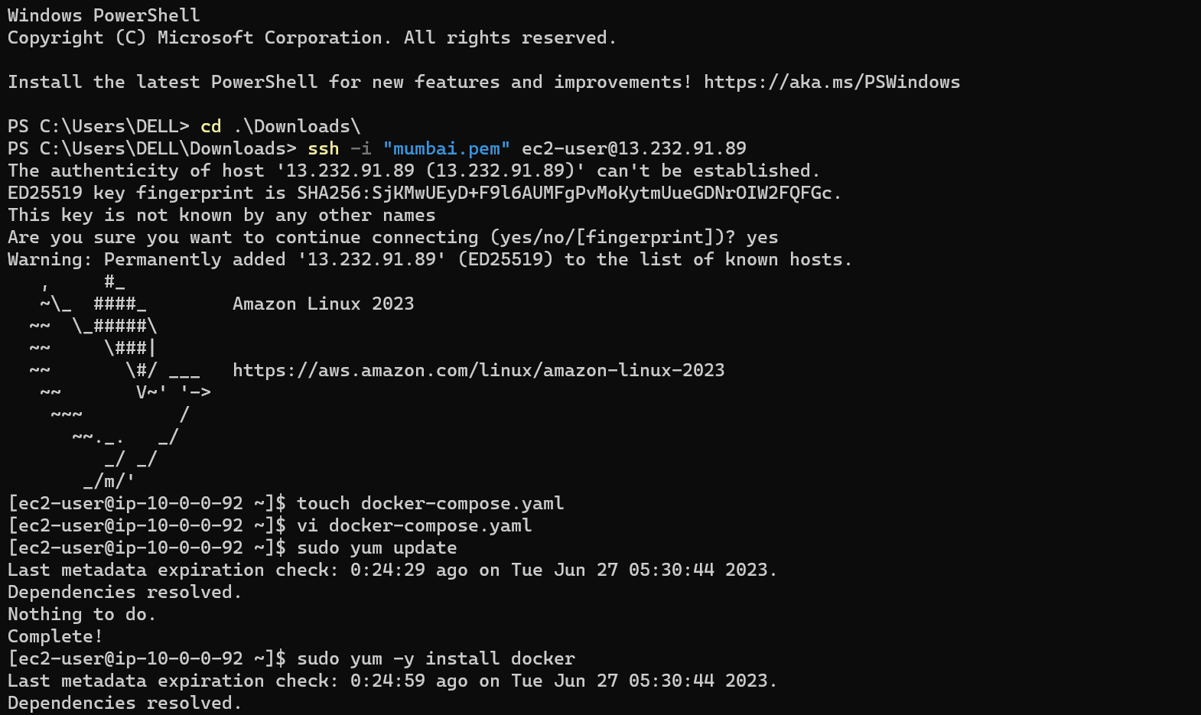

* First of all install docker by using commands.

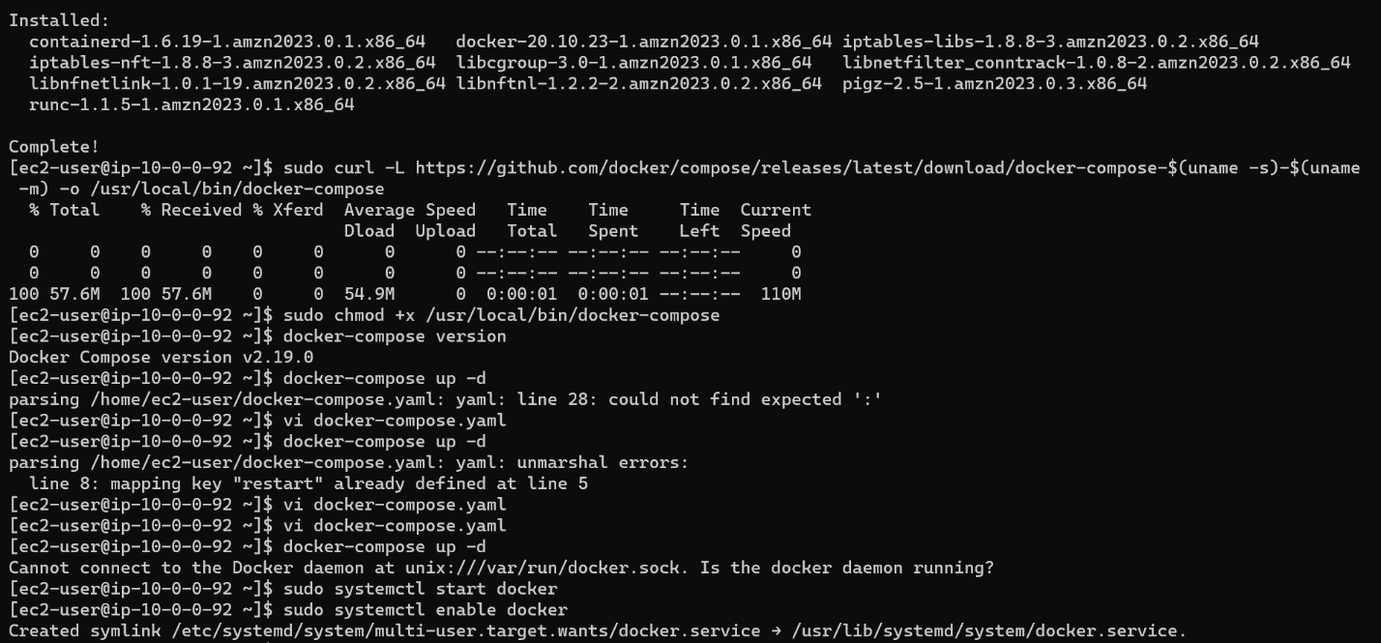

* Start and enable docker and then see the status.

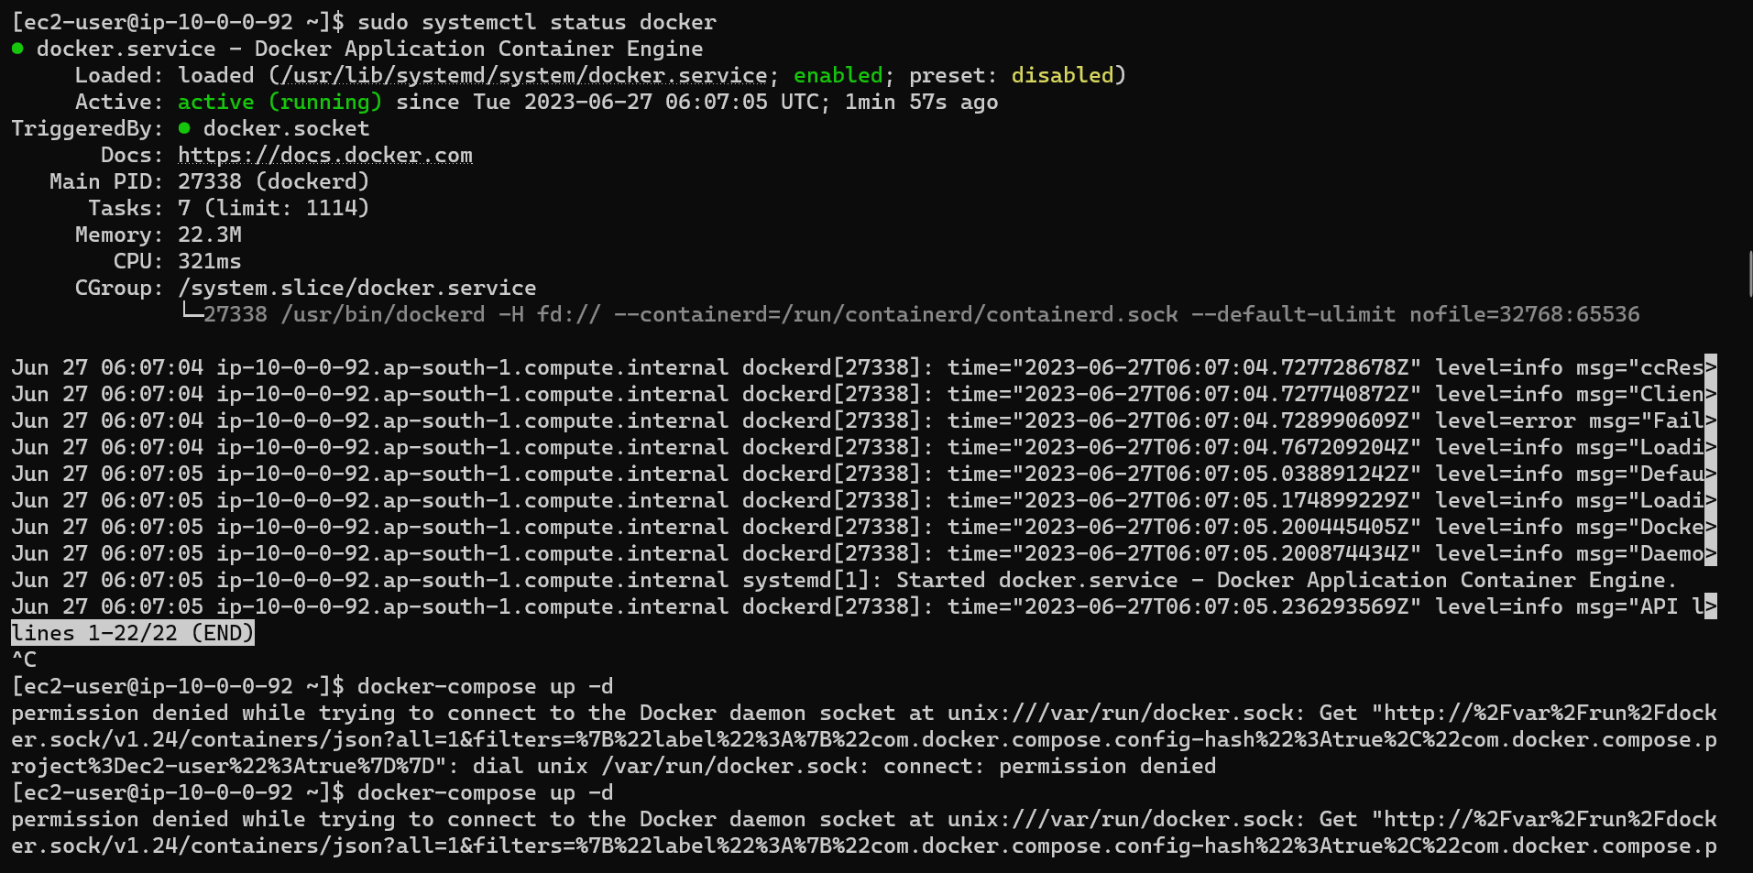

* Use command docker-compose up -d if the code is right or not.
* Change the permission using command **sudo usermod -a -G docker ec2-user.**
* Now , do docker restart. If it not work.
* Give docker compose commands.

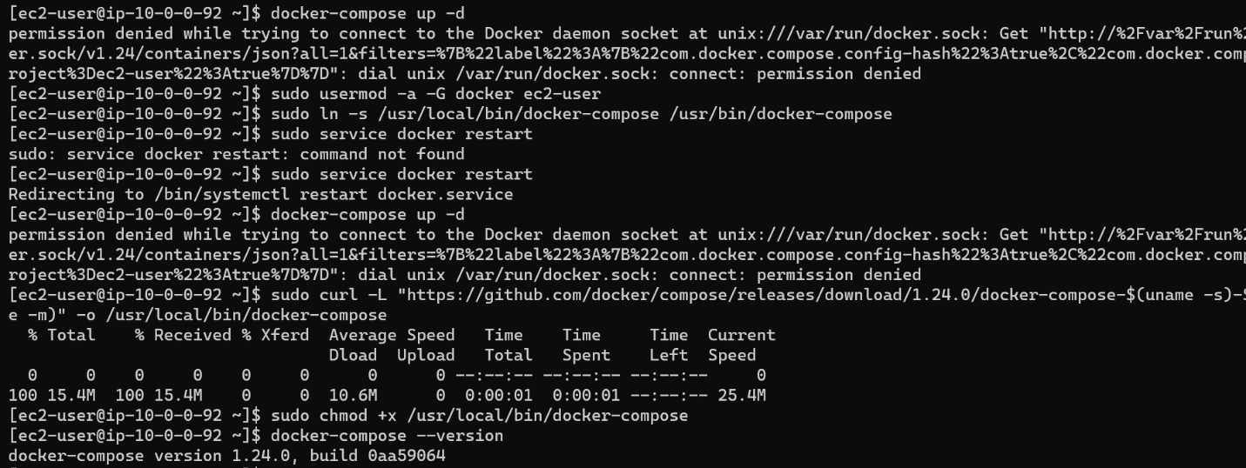

* Make sure change the version in to 1.24.0 and start ,enable and do check status.

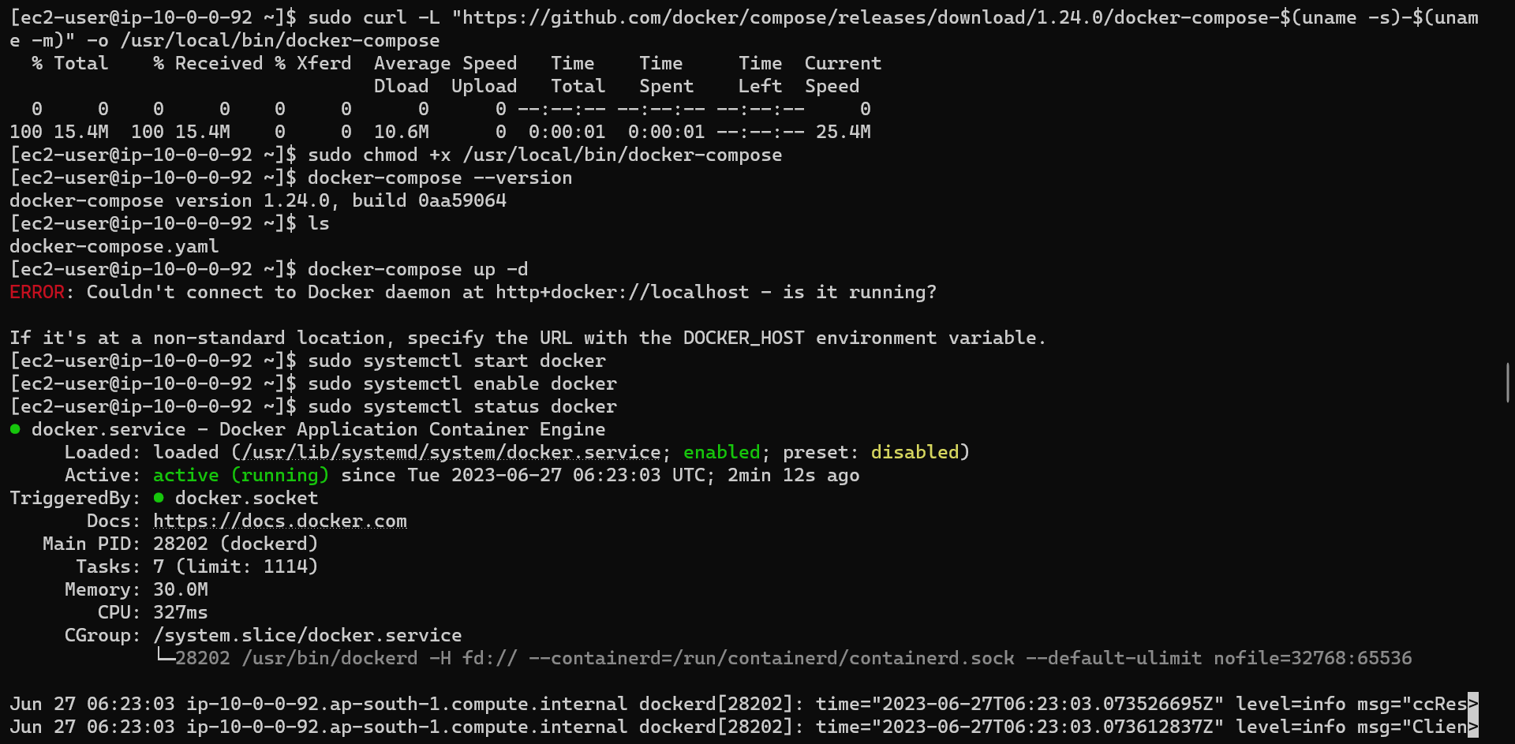

* Make exit from that instance and re-connect to that instance.

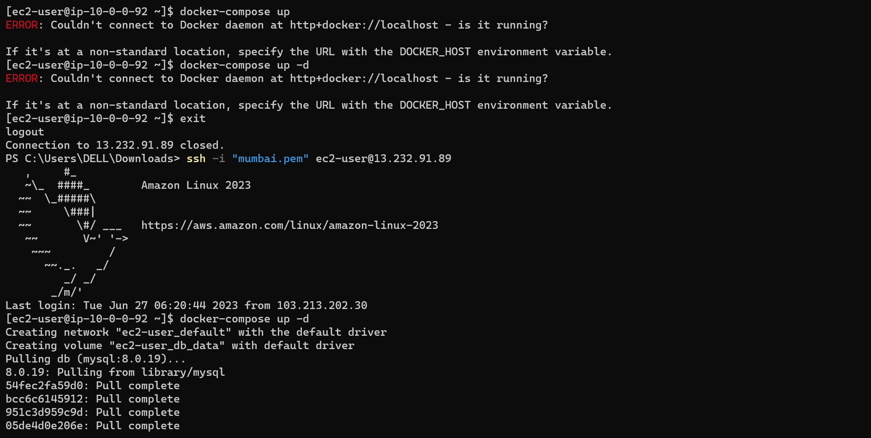

* After re-connecting the docker-compose will work.

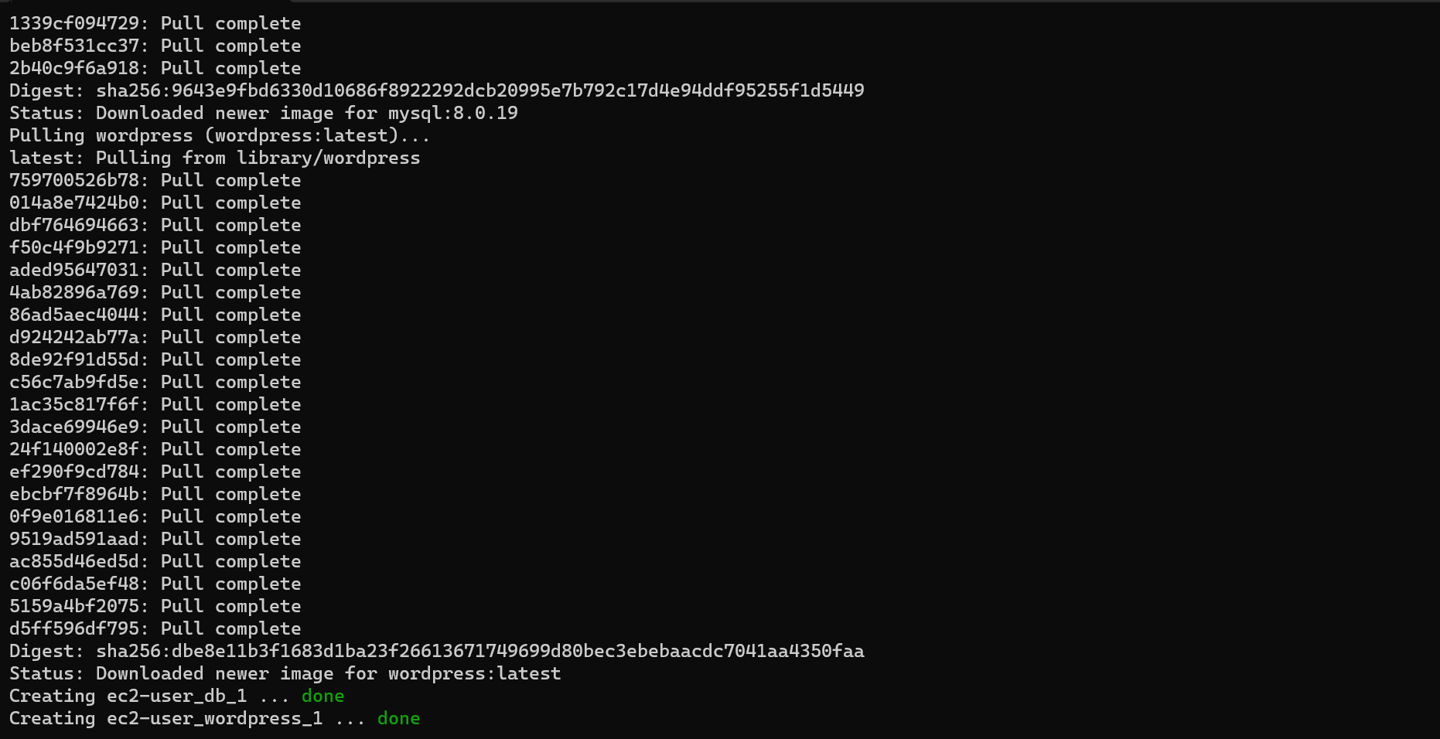

* See the output by using public - Ip address of that instance.

